onCourse CMS

Version 1
Document revisions
Who | Revision | Comment
Marek Wawrzyczny | 21/05/10 | Initial version

Table of Contents
1 DB Schema 4
2 Features 5
2.1 Page Rendering 5
2.1.1 Page components 5
2.1.2 Textile 5
2.1.3 WebBlock 5
2.2 SiteMap 5
3 Design 6
3.1 Classes 7
3.2 WebNode Classes 8
3.2.1 ish.oncourse.services.WebNodeFactory 8
3.2.2 ish.oncourse.services.WebNodeRepository 9
3.2.3 ish.oncourse.validation.WebNodeValidator 9
3.2.4 Remaining classes 9
4 Estimates/milestones 10

DB Schema
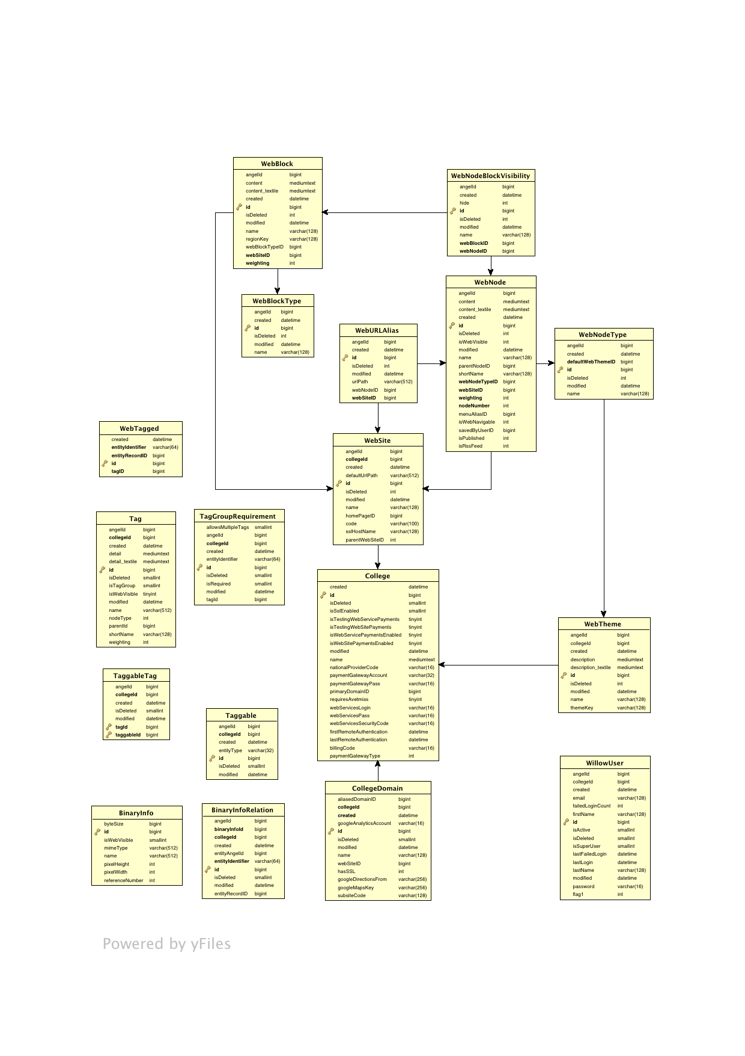

Squish Tasks
- SiteMap
- Page Rendering
  - Textile
  - Page components
- Pages
  - New Page
  - Edit Page
  - Page Options/Edit Dialog
- Administration toolbar
  - Template Injection
  - Functionality

Page Rendering

Page components
The typical implementation of page template, header, footer, sidebar, etc.

Textile
Initial implementation of textile syntax parsing – proof of concept. The code here might in fact be taken directly from Willow.

WebBlock
We will not implement Web Blocks at this point.

SiteMap
This is a page that shows a hierarchical representation of CMS web pages within the site. For each such Web Page we will have a link that takes the user to that page.

Design
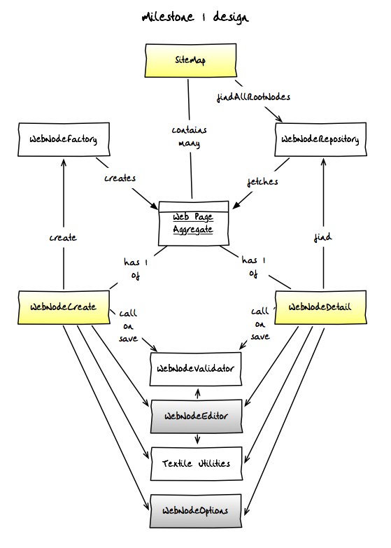

Classes
  - ish.oncourse.services.WebNodeFactory – for creating new WebNodes
  - ish.oncourse.services.WebNodeRepository – for retrieving WebNodes

  - ish.oncourse.validation.WebNodeValidator – for validating WebNodes

  - Textile Utilities – borrow existing code from Willow

  - ish.oncourse.cms.pages.webnode.WebNodeDetail – page for viewing a WebNode
  - ish.oncourse.cms.pages.webnode.WebNodeCreate – page for creating a WebNode
  - ish.oncourse.cms.pages.webnode.SiteMap – listing page for CMS pages (WebNodes)

  - ish.oncourse.cms.components.common.AdministrationBar – the administration toolbar
  - ish.oncourse.cms.components.common.xyzTab – implementations of various tabs
  - ish.oncourse.cms.components.webnode.WebNodeOptions – the WebNode AJAX form for displaying options
  - ish.oncourse.cms.components.webnode.WebNodeEditor – the WebNode AJAX form for editing content

Note that the WebNodeFactory and WebNodeRepository are used by any page rendering WebNodes.

WebNode Classes
The Web Page Aggregate defines a collection of entities that constitute a web page.
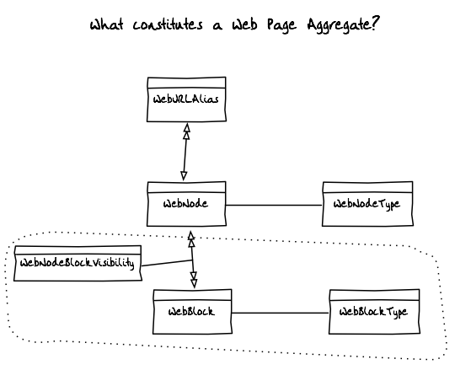

ish.oncourse.services.WebNodeFactory
Factory for creating new WebNode aggregates.
Methods:
- WebNode createWebNode(ObjectContext context, WebSite site, WebNodeType type)
- WebNode createWebNode(ObjectContext context, WebSite site, WebNodeType type, WebNode parent)
- WebNode createWebNode(ObjectContext context, WebSite site, WebNodeType type, WebNode parent, String... urlAliases)

ish.oncourse.services.WebNodeRepository
Repository for retrieval of existing WebNodes.
Methods:
- WebNode findForId(ObjectContext context, WebSite site, Integer id)
  - returns null if not found
  - throws ResultNotUniqueException if more than one record found
- WebNode findForUrlAlias(ObjectContext context, WebSite site, String urlAlias)
  - returns null if not found
  - throws ResultNotUniqueException if more than one record found
- List<WebNode> findAllRootNode(ObjectContext context, WebSite site)
  - returns empty collection if none not found

ish.oncourse.validation.WebNodeValidator
Provides validation for WebNodes (WebPageAggregate).
Methods:
- void validate(CayenneDataObject entity, ValidationResult errors)

Remaining classes
The remaining classes are:
- Textile Utilities which will be borrowed from Willow
- Main pages - tapestry:
  - WebNodeDetail – the detail page for a Web Node
  - WebNodeCreate – create a new Web Node page
  - SiteMap – list all Web Node pages
- Web Node components – tapestry:
  - WebNodeOptions – dialog for modifying Web Node options
  - WebNodeEditor – dialog for editing a Web Node
  - SiteTemplate
  - AdministrationToolbar
  - etc...

Estimates/milestones
- Version 1, Milestone 1 – week 1
  - Site Template – 5 days
    - PageLayout – 1 day
    - AdminToolbar – 1 day
    - Header, Footer and Sidebar – 1 day
    - Login → default page functionality – 1 day
    - Unit tests – 1 day
- Version 1, Milestone 2 – week 2
  - WebNodeFactory – 2 days
    - Unit tests – 1 day
    - Implementation – 1 day
  - WebNodeRepository – 2 days
    - Unit tests – 1 day
    - Implementation – 1 day
  - Textile import from Willow – 1 day
- Version 1, Milestone 3 – week 3
  - WebNodeValidator - ½ day
  - Textile unit tests - ½ day
  - WebNodeCreate – 3 days
    - WebNodeEditor – 1 day
    - WebNodeOptions – 1 day
    - WebNodeCreate – 1 day
  - WebNodeDetail – 1 day
- Version 1, Milestone 4 – week 4
  - AJAX integration
  - jQuery integration
  - HTML/CSS adaptation

